**Print to include multiple voucher details :**

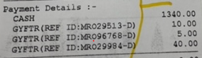

**Select Multiple vouchers :**

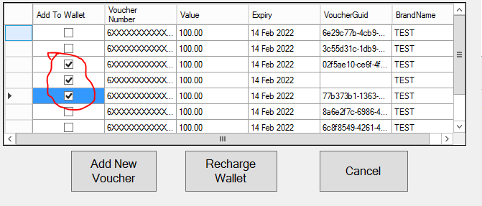

**Showing right balance :**

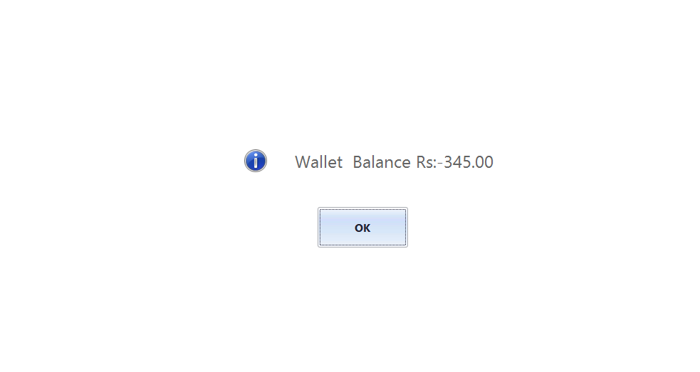

**Enter amount to be redeemed as 0 :**

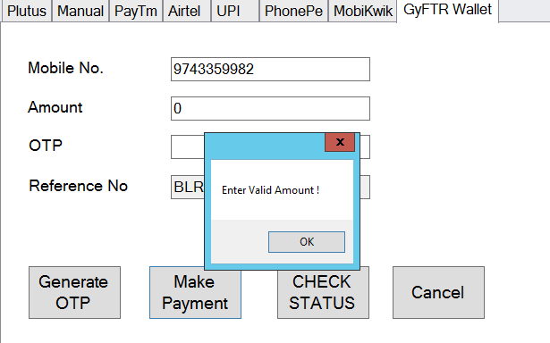

**On trying to void Transaction :**

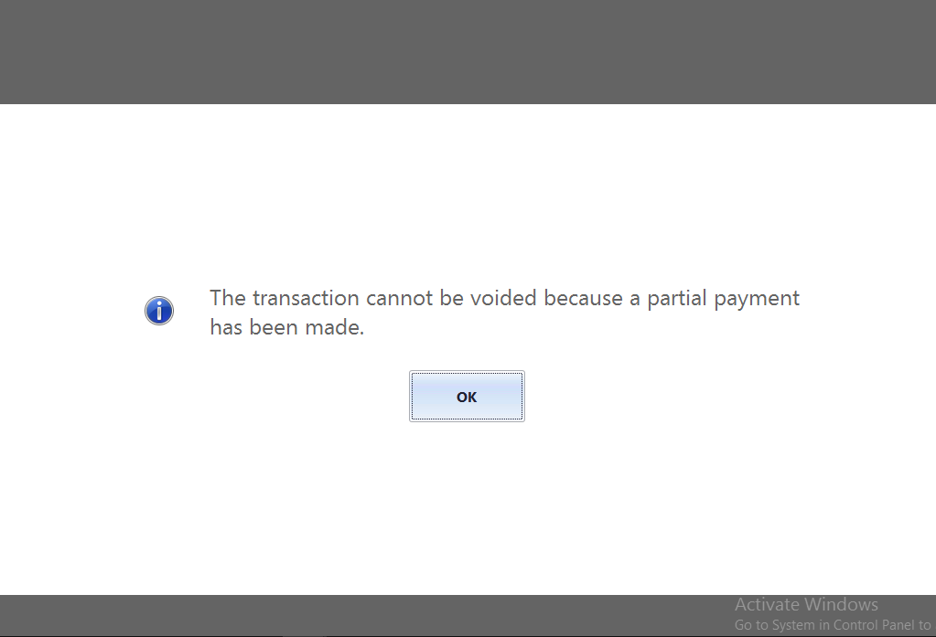

**On trying to suspend transaction :**

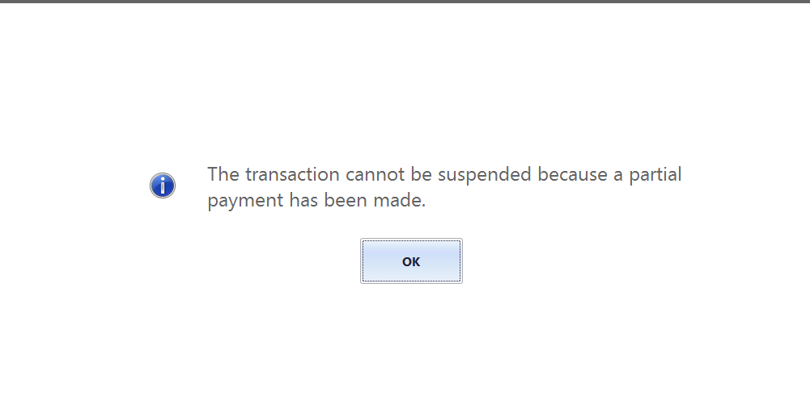

**When redemption amount is greater than invoice amount :**

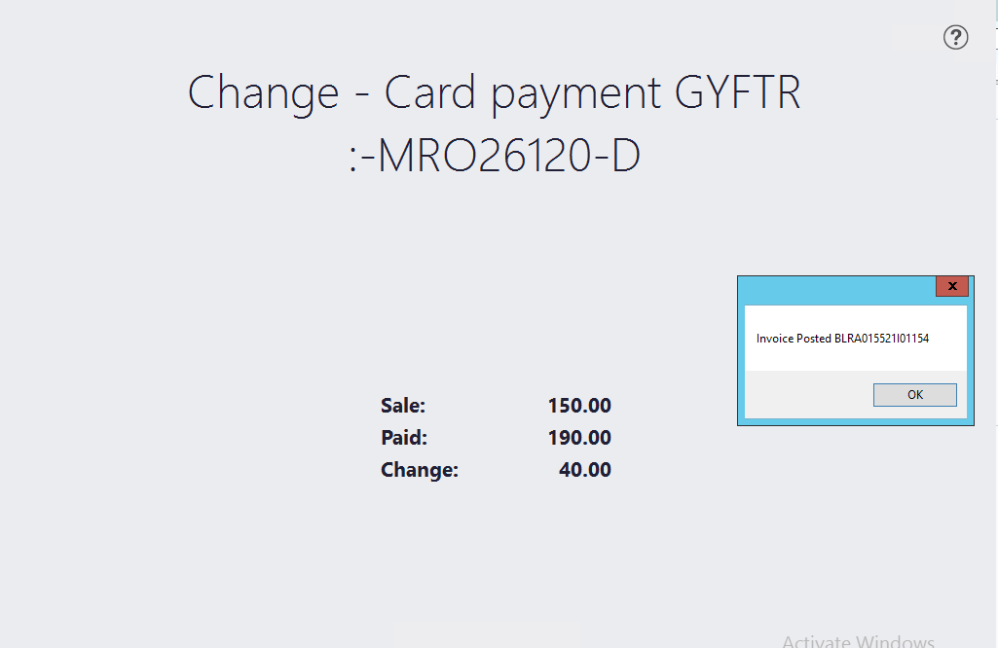

**On trying to change mobile number after OTP generation :**

